**Design and development of a solar powered agricultural Robot**

1Bakiya Lakshmi R, 2Brindha A, 3Romanus Irudaya raj R, 4Lakshmi Priya R, 5Ramani Priya R

1, 2,3,4,5 Department of Electronics & Instrumentation Engineering, SRM Institute of Science and Technology, Kattankulathur

***ABSTRACT***

***In the current scenario it is necessary to drive progress in smart farming technologies, fostering sustainable and efficient agricultural practices. The project explores the conceptualization and creation of a Smart Agricultural Robot integrated with IoT technologies and solar panels to enhance crop management and boost productivity. The proposed solution involves the development of a versatile robot capable of autonomous navigation, precision planting, and targeted weeding. Through the integration of IoT technologies in the robot, it helps for wireless communication, remote monitoring, and effective control of the robot. The advantages of using this smart agriculture will enhance energy efficiency, lower labor costs, improved crop quality and yield, and reduce the impact pesticides in the agricultural field.***

**INTRODUCTION**

In modern agriculture, the need for efficiency, resource conservation, and sustainable practices is more crucial than ever. Traditional farming requires intensive manual labor, especially for essential tasks like soil preparation, seed planting, fertilizing, and pest control. Therefore, it is easonable to explore agriculture further using advanced technology in order to keep promoting the current status. Moreover, agricultural production is a long-term cycle. Seeding, planting, nurturing, harvesting, and processing are crucial step towards chain as well. A comparative review of agricultural robots based on several criteria such as field robots, fruits and vegetable robots, animal husbandry robots **[3].** a prototype of an autonomous agriculture robot is specially designed for seed sowing task alone. It is a four wheeled vehicle which is controlled by LPC2148 microcontroller. Its works based on the precision agriculture which enables efficient seed sowing at optimal depth and at optimal distances between the crops, specific for each crop type **[8]**. A cost-effective robotic arm, developed by Politecnico of bari and the University of Lecce, tackles radicchio harvesting. Utilizing visual localization (RVL), it identifies plants in the field. The pneumatically powered arm, with a specialized gripper, cuts radicchio 10mm underground. Laboratory and field tests validate the system’s accuracy and robustness, demonstrating a promising step towards automated agriculture **[9]**.

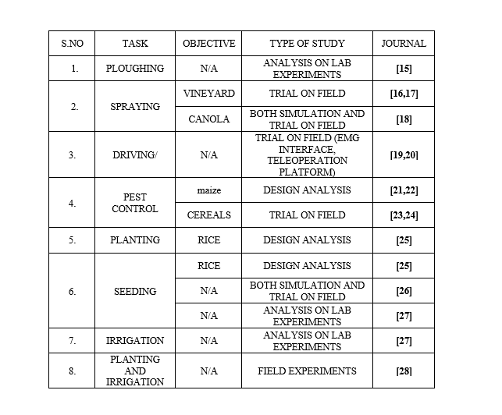

Table 1. OVERVIEW OF VARIOUS AGRICULTURAL TASKS AND THEIR STUDY ANALYSIS

The above table.1 represents the overview of various agricultural tasks and the research approaches employed in their study analysis. It highlights the different activities, from fundamental soil preparation like ploughing to specific interventions of crops like spraying, pest control for different crops. It also showcases a diverse set of methodologies like the type of study analysis which they gone through. Some tasks like ploughing and certain aspects of seeding and irrigation, have been analyzed through some lab experiments allowing for the controlled observation of specific parameters. some studies like planting, spraying have involved field trials, providing insights into real-world conditions. EMG interface and teleoperation platform for driving, indicating research into advanced control vehicles. So far we have seen some of the techniques and type of study analysis in the previous researches.

To address the above all the challenges which we have discussed earlier, the smart agriculture robot was developed as an advanced, IoT – enabled solution designed to automate these process reducing dependency on human labor and enhancing productivity. This robot leverages the power of microcontrollers, namely the ESP32 and ESP8266, to perform key agriculture tasks autonomously and with high precision. It combines the capabilities of ploughing, precise seed dropping, soil covering, fertilizer application, and water sprinkling with a medicine mixer. The robot’s integration with IoT enables wireless control and monitoring through Blynk platform, allowing farmers to operate and adjust its functions remotely via smartphone or computer.

The Smart Agriculture Robot represents a significant step toward precision farming, conserving resources, and promoting sustainable agricultural practices. This project demonstrates how technology can transform traditional farming methods, creating a more efficient and scalable model for future agricultural needs. Furthermore, its IoT and solar panel integration facilitates data collection, reducing dependency on fossil fuels, enabling farmers to make informed decisions based on real-time conditions.

**2. ROLE OF AUTOMATION**

Automation in agriculture plays a crucial role in enhancing efficiency, productivity, and sustainability by integrating advanced technologies such as robotics, artificial intelligence (AI), and the Internet of Things (IoT). Automated machinery, including precision seeders, robotic harvesters, and automated tractors, has significantly reduced labor dependency while increasing operational accuracy AI-Driven predictive analytics and machine learning enable farmers to optimize irrigation, fertilization, and pest control, leading to improved resource management and reduced environmental impact. Additionally, IoT-based smart farming systems allow real-time monitoring of soil conditions, weather patterns, and crop health, ensuring data-driven decision-making for improved yields **[7].**

**LITERATURE REVIEW**

To improve agricultural practices by providing farmers with real-time data and information about their crops, using Internet of Things (IoT) and conversational AI, an agribot was developed. Collection of data on moisture, temperature, humidity, and soil quality by intergrating sensors, which is processed using Natural Language Processing (NLP) and delivered via chatbot. This help the farmers to make informed decisions efficiently. It focuses on enhancing communication and real time data collection in agricultural sector **[1].**

The challenges faced in conventional farming as well as the modern practices in agricultural fields have been overcome by the agribot for polyhouse. The system focuses on changing the way of performing the agricultural practices by using automation, data analytics, IoT and machine learning technologies. They used Raspberry pi microprocessor for communication and ESP32 camera module for disease detection which helps in the real-time analyzation of plant health **[2].**

The different agricultural robots used in farming tasks like seeding, tilling, spraying pesticides, collecting data, and harvesting have been discussed. Some key parts like vision systems, control systems, tools, and mobile platforms to operate efficiently. Different types of robots for crops, fruits and vegetables for specialized tasks, and drones for spraying pesticides. Advanced technologies like AI, sensors, and automation improve accuracy, reduce labor, and increase productivity. These robots helps the farmers to save their time, to reduce costs, and enhance crop yields while reducing environmental impact **[3].**

The mobile robots transforming and the challenges that inconsistent terminology and planning definitions create confusion. This clarifies that the essential terms and planning attributes for autonomous agricultural robots. Key planning aspects include how robots think, understanding their environment, move in relation to tasks, planning level, resource management, their design and movement. This shows various planning approaches using algorithms and simulations to optimize robot navigation and task execution in diverse agricultural settings **[4].**

Farming tasks like seed sowing and watering was manages by this agricultural robot. The robot uses a GUI to set paths and regulates watering based on soil moisture levels. It can be applied in various settings, from large-scale farming operations to research and home gardening. The prototype aims to address labor shortages in rural India and reduce the burden on farmers. It can be extended for tasks like ploughing, weeding and pesticide spraying in future **[5].**

The farm management tool, ‘AgROS’ to assist agricultural producers in implementing robotic systems. Some previous research on farming robots says that the studies concentrate on either virtual simulations or practice field trials, but not both. Actual field maps and robotic simulations were employed in AgROS to evaluate robot efficiency prior to real-world deployment. It seeks to connect virtual testing with actual applications. These AgROS empowers farmers to comprehend and integrate new technologies such as self-driving vehicles **[6].**

The solar-powered agricultural robot(E-Bot) was designed to assist farmers with tasks like weeding, fertilizer spraying and pest control. The E-Bot is a four-wheeled, unmanned vehicle that powered using solar energy and can be controlled manually or autonomously. The integration of some features like a wireless camera for remote monitoring and independent units for different agricultural functions. The robot utilizes an MSP430 microcontroller for control and incorporates DC motor for motion and performing tasks. The development emphasizes the use of renewable energy to promote sustainable agriculture. While, it is designed for specific crops and has the potential for future enhancements **[7].**

**METHODOLOGY**

As described in the work flowchart (Fig:2), The overall robot mission aims at achieving a series of tasks like soil preparation, seed planting, fertilizing, covering the seeds, irrigation, and medicine mixing thereby covering the whole process of agriculture. This leads to great savings in labor, time, and energy in the course of cultivation. The Smart Agriculture Robot is made up of several main components that together provide a complete solution. ESP32 as the microcontroller which acts as the brain for the automation in the work. The construction and the method of working of the robot is described in the following subsections.

.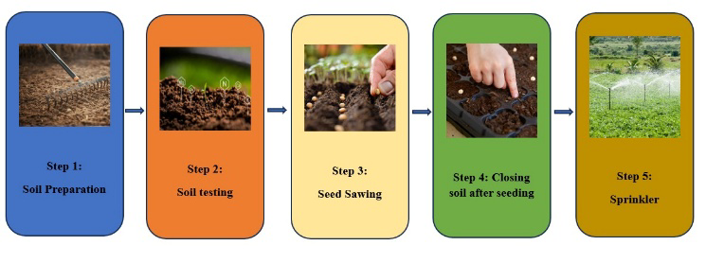

Fig:1 - WORK FLOW CHART OF THE AGRICULTURAL ROBOT

**4. ii) Soil Preparation:**

In order to prepare the soil for the farming process, The 12V DC motor driven rotational motion blades (as shown in Fig:3), within the robot to perform as a secondary source of soil preparation process after the tractor-based inaccurate ploughing. Improper breakage of soil and ploughing of soil can lead to improper harvesting and may also make the plant lacking with nutrient enrichment**.** The proper ploughing and the breakdown of soil process by the rotational blades will enhance the seed plantation and appropriate nutrient uptake of the plants from the soil.

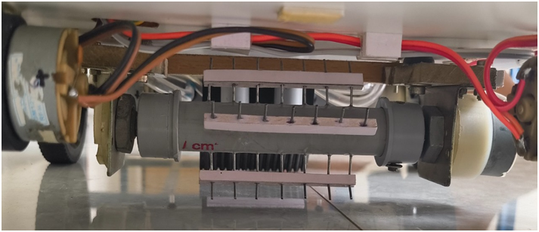

Fig:2 - PLOUGHING TOOL WITH BLADES

**4.iii) Seed dropping and fertilizer management system:**

Spaced seeding method is one of the proven practices that will ensure the profitable yield of the invest. The one in agriculture robot that works with adjustable requirements. The seed dropping and powdered fertilizer dispensing mechanism works by using the MG996R servo motor with adjustable intervals to collect seeds and release them. This interval is adjustable to prevent overcrowding while allowing maximum plant growth. This ensures that the seeds are nourished from the start, enabling smooth germination and growth. The construction of the seed dropping and the fertilizer system is shown in Fig:4

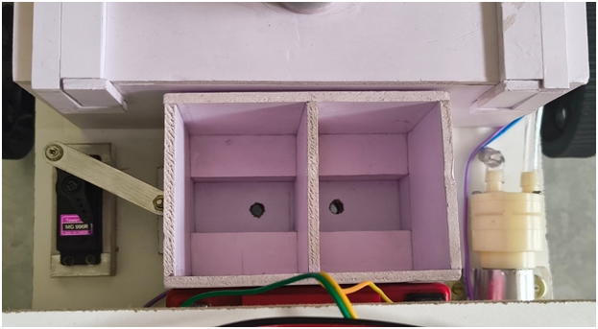

Fig:3 - SEED PLANTATION AND FERTILIZER TOOL STRUCTURE AND CONSTRUCTION

**4. iv) Soil closing and irrigation system:**

After the seeds and fertilizers have been placed in the soil, covering the grown ones properly is needed so that animals such as birds and wind will not destroy them. So, The robot has a rubber-based flexible covering system is shown in Fig:5 at its back. The covering material, while the robot is moving forward pushes the soil covering the seeds and acts ideal for proper germination.

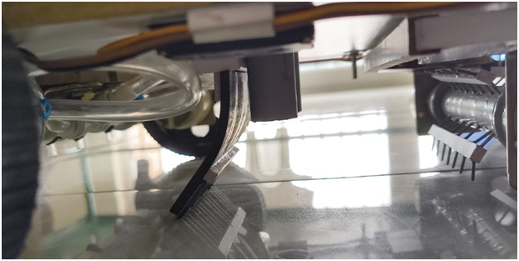

Fig:4 - SOIL CLOSING MECHANISM

Adequate irrigation is critical for seed germination and plant growth. The Smart Agriculture robot is equipped with a 1.5-liter water tank for irrigation (Fig:6). The watering system features a 12V DC water compressor that pumps water from the tank and distributes it evenly through a slotted 1-inch PVC pipe. This system allows for controlled spraying and drip irrigation, thus optimizing the use of water and preventing wastage. A uniform mixing of agricultural chemicals and nutrients is necessary for their desired effect. The robot is provided with an inbuilt mixing system in the water tank. It possesses an electric motor of 12V DC driving a mixing blade that thoroughly stirs the chemicals or nutrients in the water. When required, the mixing motor is switched on through the relay module, it starts the mixing process.

Fig:5 - IRRIGATION SYSTEM

**4.v) Solar panel Integration**

The solar power system is integrated into the robot to enhance the sustainability and reduce the dependency on external charging sources, which enables the robot to harness solar energy during daytime operations, supporting energy source in agricultural fields. The system utilizes a solar panel connected to a DC-DC boost converter, which steps up the voltage to a suitable level required to charge a 12V lithium battery pack. The boost converter ensures a stable output voltage, typically set between 13.0V to 13.6V, allowing efficient charging without overloading the battery. A Schottky diode is placed in series between the converter and the battery to prevent reverse current flow.

Fig:6 – SOLAR PANEL INTEGRATION

**4. GRAPHICAL USER INTERFACE:**

The developed Smart Agriculture Robot was successfully integrated with the Blynk IoT platform is shown in Fig:7. The interface provides real-time monitoring and control features for various agricultural operations such as post ploughing, seed planting, soil covering, irrigation, fertilizer mixing and application.

Fig:7 - IoT INTERFACE DEVELOPMENT FOR THE AGRICULTURE ROBOT

**5. RESULTS:**

The results demonstrate that the robot can be remotely controlled using a smartphone or PC within the range of the same Wi-Fi network. This enables the farmer to initiate or stop any function reliably within a limited local area, ensuring efficient and precise operation without requiring constant physical presence. The solar charging integration reduces downtime, supports long-term operation, and enhances the ecofriendly nature of the robot, especially useful in remote farming areas with limited access to electricity.

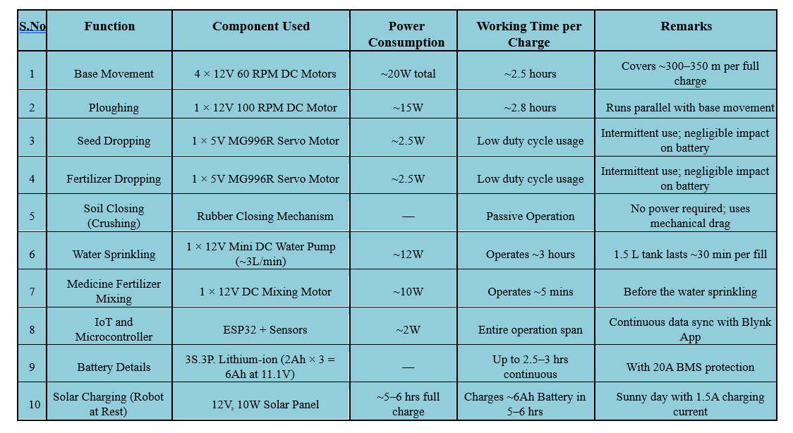

Table 2. TESTING RESULTS OF THE BOT DURING VARIOUS OPERATIONS

The recorded data represents performance metrics collected through real-time testing of the smart agriculture robot during various operational stages. Parameters such as energy usage, runtime, and area covered were carefully calibrated and measured during experimental field trials. Each core function - ploughing, dispensing of seeds and fertilizers, soil covering using a passive rubber based mechanism, mixing of liquid fertilizers, and irrigation was individually evaluated to capture its specific energy and time requirements, ensuring a detailed understanding of battery utilization per operation cycle.

**6. CONCLUSION:**

As a conclusion, The Smart Agriculture Robot is a significant leap forward in modern farming. The robot will minimize labor while automating soil preparation, seed planting, fertilization, irrigation, and chemical mixing; its ESP32 and ESP8266 microcontroller will guarantee smooth operation and IoT-enabled remote monitoring. The efficient power management system will be a great assert: lithium-ion batteries coupled with DC converters will improve the sustainability and usability of the robot. Due to its strong design and multi-functionality, the robot offers a low-cost and ingenious solution to producing more agricultural by-products while promoting green farming practices.

**REFERENCE:**

1. P. S. Venkata Reddy, K. S. Nandini Prasad and C. Puttamadappa, "Conversational AI bot based on IoT Knowledgebase for Smart Agriculture," 2024 International Conference on Knowledge Engineering and Communication Systems (ICKECS), Chikkaballapur, India, 2024, pp. 1-7, Doi: 10.1109/ICKECS61492.2024.10616582.

2. S. M. Veer, S. R. Wadke, P. V. Shinde and A. R. Kelkar, "Agri-Bot for Polyhouse," 2024 1st International Conference on Innovative Sustainable Technologies for Energy, Mechatronics, and Smart Systems (ISTEMS), Dehradun, India, 2024, pp. 1-6, Doi: 10.1109/ISTEMS60181.2024.10560343.

3. Cheng, C.; Fu, J.; Su, H.; Ren, L. Recent Advancements in Agriculture Robots: Benefits and Challenges. *Machines* 2023, *11*, 48. <https://doi.org/10.3390/machines11010048>

4. Moysiadis, V.; Tsolakis, N.; Katikaridis, D.; Sorensen, C.G.; Pearson, S.; Bochtis, D. Mobile Robotics in Agricultural Operations: A Narrative Review on Planning Aspects. *Appl. Sci.* **2020**, *10*, 3453. <https://doi.org/10.3390/app10103453>.

5. K. Ramesh, K. T. Prajwal, C. Roopini, M. Gowda M.H. and V. V. S. N. S. Gupta, "Design and Development of an Agri-bot for Automatic Seeding and Watering Applications," 2020 2nd International Conference on Innovative Mechanisms for Industry Applications (ICIMIA), Bangalore, India, 2020, pp. 686-691, Doi: 10.1109/ICIMIA48430.2020.9074856.

6. Tsolakis, N.; Bechtsis, D.; Bochtis, D. AgROS: A Robot Operating System Based Emulation Tool for Agricultural Robotics. *Agronomy* **2019**, *9*, 403. <https://doi.org/10.3390/agronomy9070403>

7. P.Jothimurugan et al., "Solar E-Bot for Agriculture," 2013 Texas Instruments India Educators' Conference, Bangalore, India, 2013, pp. 125-130, doi: 10.1109/TIIEC.2013.29.

8. N. S. Naik, V. V. Shete and S. R. Danve, "Precision agriculture robot for seeding function," *2016 International Conference on Inventive Computation Technologies (ICICT)*, Coimbatore, India, 2016, pp. 1-3, doi: 10.1109/INVENTIVE.2016.7824880.

9. Agricultural robot for radicchio harvesting,

<https://doi.org/10.1002/rob.20131>

10. D. N. Vinod and T. Singh, "Autonomous Agricultural Farming Robot in Closed Field," 2018 3rd IEEE International Conference on Recent Trends in Electronics, Information & Communication Technology (RTEICT), Bangalore, India, 2018, pp. 1-7, doi: 10.1109/RTEICT42901.2018.9012118.

11. Shiva Gorjian, Hossein Ebadi, Max Trommsdorffs, H. Sharon, Matthias Demant, Stephan Schindele, “*The advent of modern solar-powered electric agricultural machinery: A solution for sustainable farm operations”, Journal of Cleaner Production,* Volume 292,2021,126030.

12. Malaver, A.; Motta, N.; Corke, P.; Gonzalez, F. Development and Integration of a Solar Powered Unmanned Aerial Vehicle and a Wireless Sensor Network to Monitor Greenhouse Gases. *Sensors* **2015**, *15*,4072-4096. <https://doi.org/10.3390/s150204072>

13. S. A. Amrita, E. Abirami, A. Ankita, R. Praveena and R. Srimeena, "Agricultural Robot for automatic ploughing and seeding," 2015 IEEE Technological Innovation in ICT for Agriculture and Rural Development (TIAR), Chennai, India, 2015, pp.17-23, doi: 10.1109/TIAR.2015.7358525.

14. Wolfert, S., Ge, L., Verdouw, C., &Bogaardt, M. J. (2017). *Big data in smart farming–a review*. Agricultural Systems, 153, 69-15.Anil, H.; Nikhil, K.S.; Chaitra, V.; Sharan, B.S.G. Revolutionizing Farming Using Swarm Robotics. In Proceedings of the 2015 6th International Conference on Intelligent Systems, Modelling and Simulation, Kuala Lumpur, Malaysia, 9–12 February 2015; pp. 141–147.

15. Adamides, G.; Katsanos, C.; Constantinou, I.; Christou, G.; Xenos, M.; Hadzilacos, T.; Edan, Y. Design and development of a semi-autonomous agricultural vineyard sprayer: Human–robot interaction aspects. *J. Field Robot.* **2017**, *34*, 1407–1426.

16. Berenstein, R.; Edan, Y. Human-robot collaborative site-specific sprayer. *J. Field Robot.* **2017**, *34*, 1519–1530.

17. hou, X.; He, J.; Chen, D.; Li, J.; Jiang, C.; Ji, M.; He, M. Human-robot skills transfer interface for UAV-based precision pesticide in dynamic environments. *Assem. Autom.* **2021**, *41*, 345–357.

18. Oliveira, L.F.P.; Moreira, A.P.; Silva, M.F. Advances in Agriculture Robotics: A State-of-the-Art Review and Challenges Ahead. *Robotics* **2021**, *10*, 52.

19. Skillful Viniculture Technology (SVTECH), Action “Reinforcement of the Research and Innovation Infrastructure”, Operational Programme “Competitiveness, Entrepreneurship and Innovation”, NSRF (National Strategic Reference Framework) 2014-2020 Available online: [**http://evtar.eu/en/home_en/**](http://evtar.eu/en/home_en/) (accessed on 10 May 2021).

20. Del Cerro, J.; Barrientos, A.; Sanz, D.; Valente, J. *Aerial Fleet in RHEA Project: A High Vantage Point Contributions to ROBOT 2013*; Armada, M.A., Sanfeliu, A., Ferre, M., Eds.; Advances in Intelligent Systems and Computing; Springer: Cham, Switzerland, 2014; Volume 252, ISBN 978-3-319-03412-6.

21. Valente, J.; Del Cerro, J.; Barrientos, A.; Sanz, D. Aerial coverage optimization in precision agriculture management: A musical harmony inspired approach. *Comput. Electron. Agric.* **2013**, *99*, 153–159.

22. Conesa-Muñoz, J.; Valente, J.; del Cerro, J.; Barrientos, A.; Ribeiro, A. A Multi-Robot Sense-Act Approach to Lead to a Proper Acting in Environmental Incidents. *Sensors* **2016**, *16*, 1269.

23. Gonzalez-de-Santos, P.; Ribeiro, A.; Fernandez-Quintanilla, C.; Lopez-Granados, F.; Brandstoetter, M.; Tomic, S.; Pedrazzi, S.; Peruzzi, A.; Pajares, G.; Kaplanis, G.; et al. Fleets of robots for environmentally-safe pest control in agriculture. *Precis. Agric.* **2017**, *18*, 574–614.

24. Noguchi, N.; Barawid, O.C. Robot Farming System Using Multiple Robot Tractors in Japan Agriculture. *IFAC Proc. Vol.* **2011**, *44*, 633–637.

25. Blender, T.; Buchner, T.; Fernandez, B.; Pichlmaier, B.; Schlegel, C. Managing a Mobile Agricultural Robot Swarm for a seeding task. In Proceedings of the IECON 2016-42nd Annual Conference of the IEEE Industrial Electronics Society, Florence, Italy, 23–26 October 2016; pp. 6879–6886.

26. Anil, H.; Nikhil, K.S.; Chaitra, V.; Sharan, B.S.G. Revolutionizing Farming Using Swarm Robotics. In Proceedings of the 2015 6th International Conference on Intelligent Systems, Modelling and Simulation, Kuala Lumpur, Malaysia, 9–12 February 2015; pp. 141–147

27. Pramod, A.S.; Jithinmon, T.V. Development of mobile dual PR arm agricultural robot. *J. Phys. Conf. Ser.* **2019**, *1240*, 012034.